Date: January 16, 2025

To: Weber County Board of County Commissioners

From: Ronna Tidwell

Community Development Department

Agenda Date: January 21, 2025

Subject: **Request to declare certain parcels, within and near Midland Drive and Pennsylvania Avenue, as Surplus Property**

Attachments: A - Vicinity Map with Aerial Photo

# _____________________________________________________________________________________

**Summary:**

UDOT has reviewed county land ownership records within and near Midland Drive and Pennsylvania Avenue and has determined that there are eight Weber County owned parcels that can be better utilized and maintained if owned by UDOT for upcoming Interchange Projects. These eight parcels are situated in or along future and existing road rights-of-ways. See Attachment A for a vicinity map and an approximate location for all parcels.

The parcels that UDOT has inquired about are identified by the following tax identification numbers:

|  |  |  |  |  |  |
| --- | --- | --- | --- | --- | --- |
| Parcel ID# | Sqft | Parcel ID# | Sqft | Parcel ID# | Sqft |
| * 15-102-0036 | 952 | * 14-051-0008 | 3000 | * 14-051-0009 | 7125 |
| * 14-051-0011 | 7072 | * 14-051-0007 | 1494 | * 14-037-0020 | 435 ± |
| * 14-037-0021 | 435 ± | * 14-031-0038 | 435 ± |  |  |

Weber County has no intended use for the listed properties; therefore, it is recommended that the parcels be declared as surplus and offered to UDOT. In order to convey real property, the County Commission must first take action to review and officially declare parcels as surplus to the county’s needs.

Attachment A

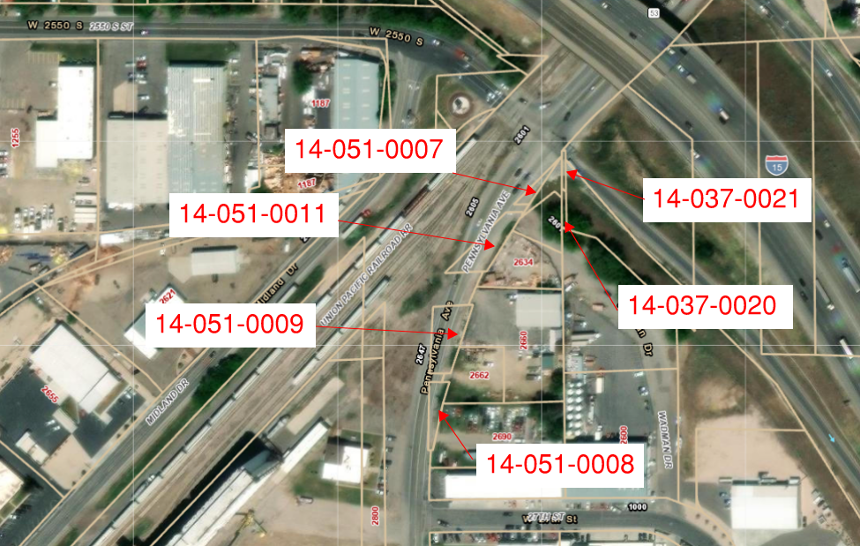

Attachment A (Cont.)

